AI beats professional players at Super Smash Bros. video game

With the rapidly developing technology of the modern era, and the increasing interest of making the wonderful inventions and visions of motion pictures become a reality, large companies, and individuals alike, are competing to achieve these goals. In particular, artificial intelligence (AI) and machine learning have taken the center stage of the nation to realize certain ideas such as creating autonomous cars and robots to improve society. While AI and machine learning have important applications to real-world ideas, they have also been relevant in various forms of human entertainment, and more specifically, the game industry. This area of study has seen the creation of AI's that have been able to compete with humans on a competitive level, and in some cases defeat the best players in the world in board games such as, Chess and Go. These board games are strategy games, and the AI's developed can become successful from analyzing and studying a large amount of data and permutations to plan many moves ahead. However, there is a completely different game genre, notably multiplayer video games that AI has been making great strides in.

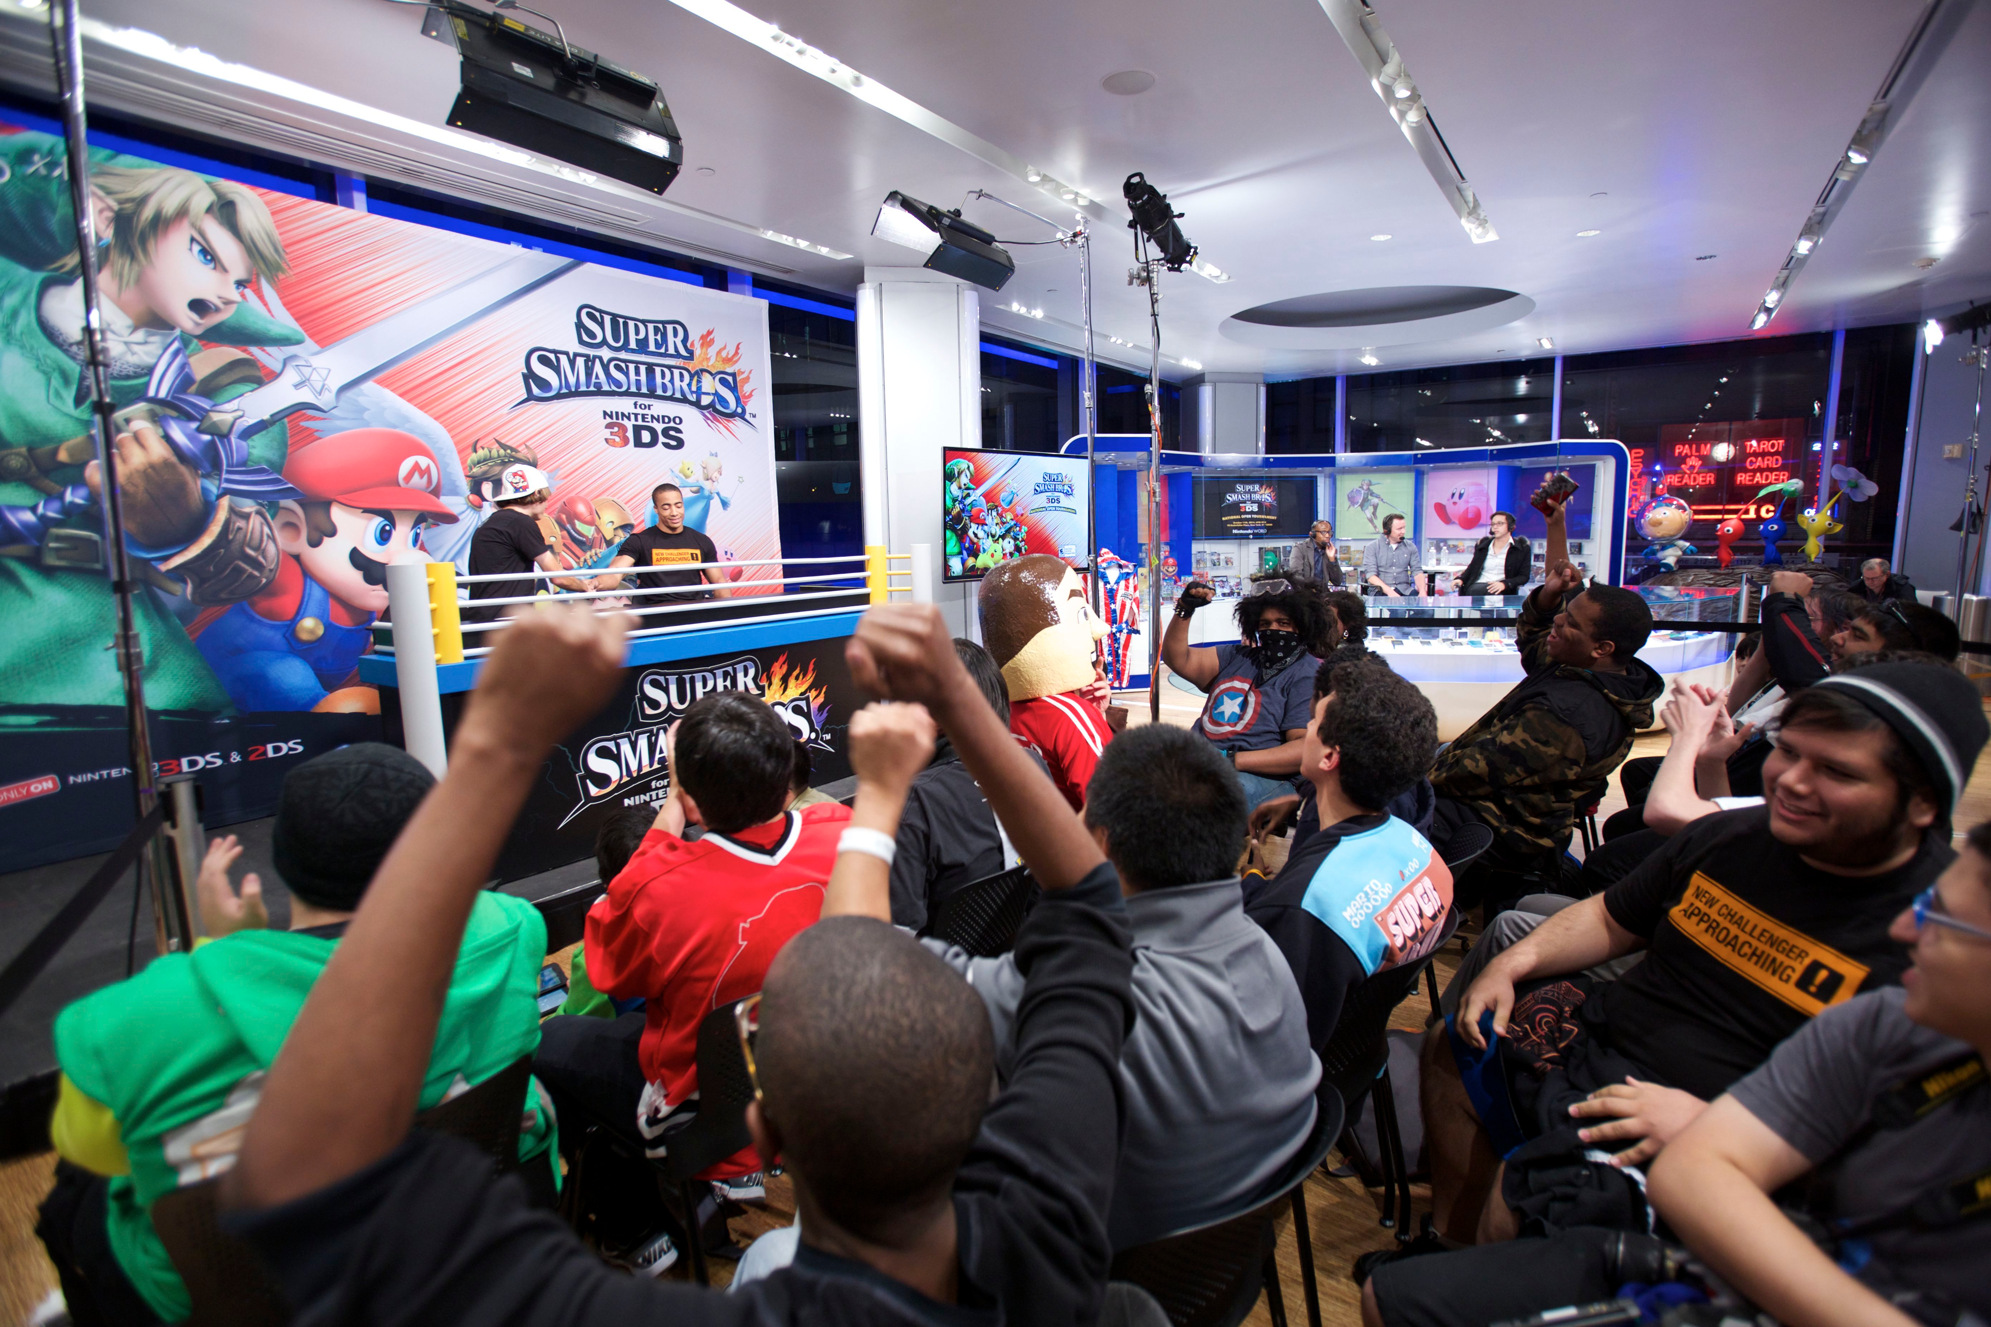 Earlier this year, a team from MIT, led by Vlad Firoiu, had taken artificial intelligence to conquer the timeless, and still widely popular video game called Super Smash Bros. Melee (SSBM) on the Nintendo GameCube. SSBM is a fighting multiplayer video game that can have 2-4 players competing at the same time, in which the goal is to attack your opponents and knock them out of the arena. Using machine-learning algorithms via reinforcement learning, Firoiu's team programmed an AI to play as a character in SSBM to compete against human opponents. After only two weeks of the AI playing the game against the in-game CPU, and against itself, it was able to defeat ten of the top 100 players in the world.

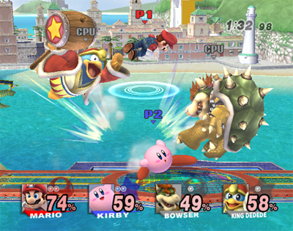 In contrast to strategy games where AI can use deep machine learning to study every aspect of the game, and analyze a large number of previously played games to develop a strategy to plan many moves in advance, SSBM is a dynamic multiplayer game, in which the AI "can't work out many moves in advance" (Revell, 1). This type of game poses a new set of problems for an AI, in which players have to be able to think on their feet, respond to attacks from different numbers of opponents, and rely on one's reaction time to be successful. In addition, attacks can have a "downside, as some can be used against the player" (Revell, 1). Thus, the AI has to be able to learn and adapt in an entirely different way from previous games that they have been successful in.

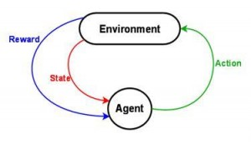To program such an AI, Firoiu's team used a branch of machine learning, called "deep learning", in which the AI is given the ability to learn and adapt without an explicit program, calling on large amounts of data (i.e. game objects, opponents, environment, attacks, etc.) to extract useful information, patterns and combinations, and strategies to be successful. Firoiu's team used a branch of machine learning, called "reinforcement learning", where the AI improved its gameplay by playing the in-game CPU, and itself repeatedly. In doing this, the AI performed a wide variety of actions, with the goal to maximize the possibility of obtaining a given reward or incentive (i.e. defeating the opponent). Through trial-and-error, and repetition, the AI was able to learn incredibly quickly, optimize performance, and choose certain attack combinations that yielded the highest success rate. While several other AIs for different games learn by watching the screen, this AI acted as an "in-game computer player", and learned by "feeding the AI coordinates of the in-game items, opponents, and map elements" (Coldeway, 1). The AI went from not being able to beat the in-game AI (which could be defeated by practically any human), to being able to beat it in a couple hours, to then being able to defeat world-class human players a couple weeks later.

While some people might view this as a meaningless stride in the artificial intelligence and machine learning setting, I believe that the success of this AI shows significant optimism in the advancement of AI to a wide variety of real-world applications. Even though this particular project, and AI, created a computer that was able to beat highly skilled individuals at a video game, I viewed it as an idea prevailing in a less-explored area of study. The AI was not only able to learn the concept of the game, but also was able to adapt and develop strategies and combinations that allowed it to beat top players in the world. What the AI was able to accomplish in only two weeks was an incredibly remarkable feat, as it takes humans months to learn, and several years to hone the learned skills. The unreal speed in which the AI was able to conquer the game (something that can't be achieved by humans) shows the capacity for artificial intelligence to take on more complex and challenging applications such as creating autonomous vehicles for example. While progress is being made to eventually make fully independent, autonomous vehicles, there are still people who believe that either these autonomous cars will never be realized, or that they will never be completely independent. However, I believe that similar to the video game AI and its success, autonomous vehicles will be created sooner than everyone thinks by introducing the AI to a large amount of data and presenting it to every thinkable scenario and situation using deep learning and reinforcement learning methods.

Bibliography

Coldewey, Devin. "Super Smash Borg Melee: AI Takes on Top Players of the Classic Nintendo Fighting game."TechCrunch. TechCrunch, 24 Feb. 2017. Web. 12 Mar. 2017. <https://techcrunch.com/2017/02/24/super-smash-borg-melee-ai-takes-on-top-players-of-the-classic-nintendo-fighting-game/>

Fingas, Jon. "MIT's 'Super Smash Bros.' AI Can Compete with Veteran Players." Engadget. N.p., 26 Feb. 2017. Web. 12 Mar. 2017. <https://www.engadget.com/2017/02/26/super-smash-bros-ai-competes-with-top-players/>

Gershgorn, Dave. "A Super Smash Bros-playing AI Has Taught Itself How to Stomp

Professional Players."Quartz. Quartz, 23 Feb. 2017. Web. 12 Mar. 2017. <https://qz.com/917221/a-super-smash-bros-playing-ai-has-taught-itself-how-to-stomp-professional-players/>

Revell, Timothy. "AI Beats Professional Players at Super Smash Bros. Video Game." New Scientist. N.p., 24 Feb. 2017. Web. 12 Mar. 2017. <https://www.newscientist.com/article/2122452-ai-beats-professional-players-at-super-smash-bros-video-game/>

Schmidhuber, Jürgen. "Deep Learning in Neural Networks: An Overview." Deep Learning in Neural Networks: An Overview. N.p., Jan. 2015. Web. 12 Mar. 2017. <http://www.sciencedirect.com/science/article/pii/S0893608014002135>